Q 3:DFD diagram of flipkart

Level 1 dfd : which describe only user and admin process

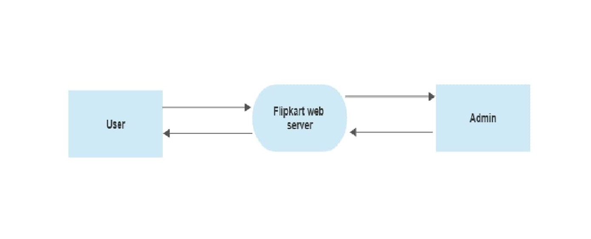

Level 2 dfd: a complex method of describe user and admin data flow chart of sign up, shopping,order , cart , payment , user data storage, payment data storage.

